Prerequisites for ABAP for HANA Webinar:
- Register for an Amazon Web Services account and configure it to run an SAP HANA instance.
- Locate and connect SAP NetWeaver on HANA solution to AWS.
- Activate your SAP NetWeaver Instance.
Registering for Amazon Web Services(AWS)
Registration for AWS is free, however it will cost money to run instances on AWS. The rate you will be charged per instance depends on both the hardware required to run the instance and how much it is utilized.
CHARGES WILL ONLY BEGIN TO ACCRUE TOWARDS THE END OF THE “Locate and Connect SAP NetWeaver on HANA Solution to AWS” step. I will mark clearly in BOLD RED text that you will start being charged.
You will also be able to terminate the solution at any point for the CAL.SAP.COM webpage to stop additional charges.

Step 1: Registering for an AWS account
Navigate to https://aws.amazon.com using your preferred web browser.
Click the yellow “Sign In to Console” button in the top right corner.
On the next page, enter the email address you wish to associate with your account, and select the radio button next to “I am a new user”:
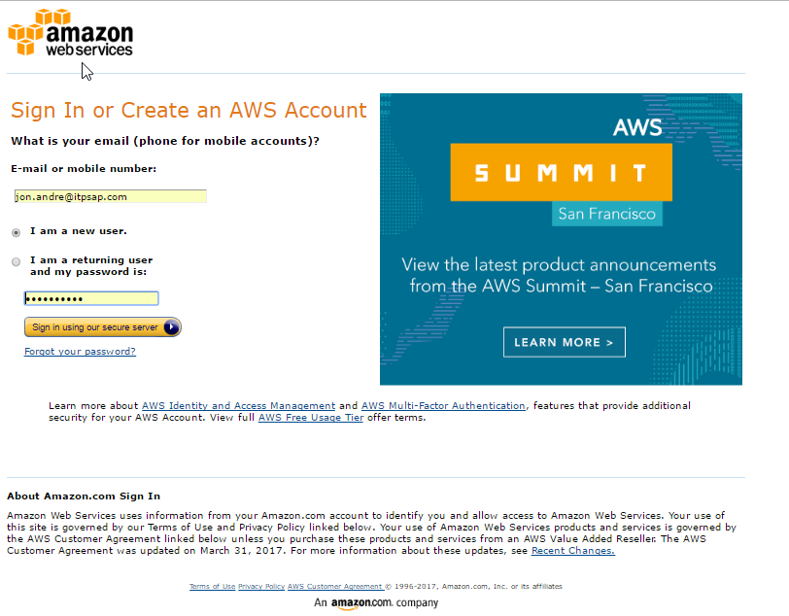

Step 2: Enter required information
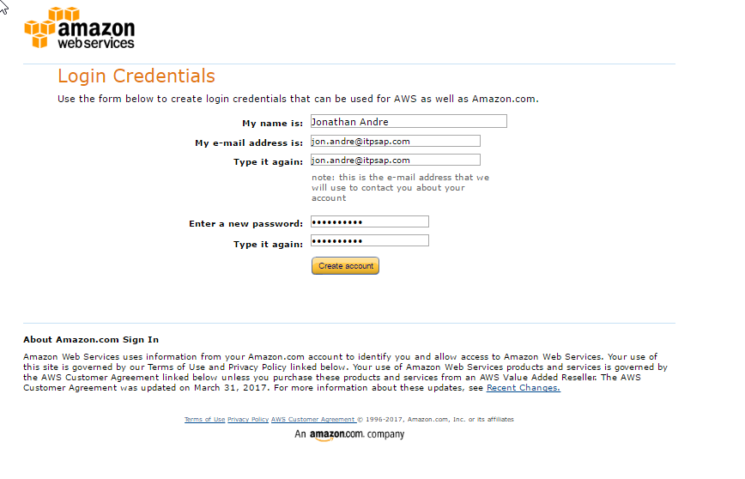

When you arrive at this screen, make sure to select the Basic account. This is the best option for those who are just using this as a test system, and is also the cheapest option:
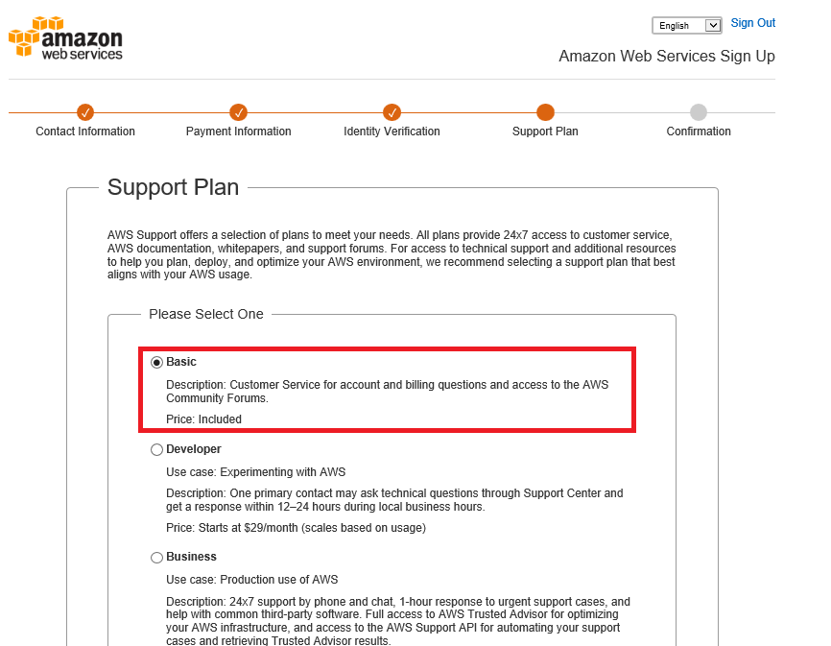

Step 3: Register a payment method

Select the drop down under the registered name and select “My Account” (outlined in red in the screenshot):
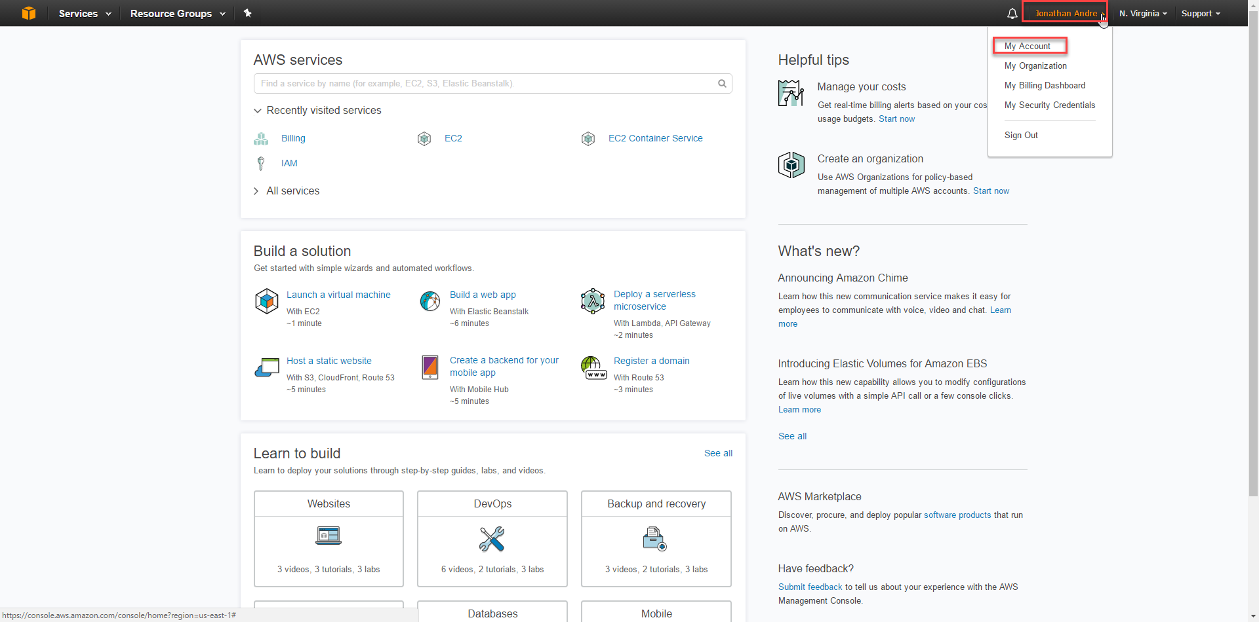
Within the “My Account” menu, click the “Payment Methods” test on the left side of the page. Form here, follow the prompts to add a new credit card.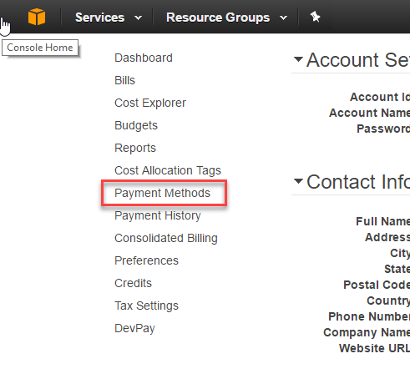

Step 4: After adding your payment method, click on the orange cube on the top left of the screen to navigate back to the console home page. From here, find and click on the “IAM” text to manage security settings for your profile:
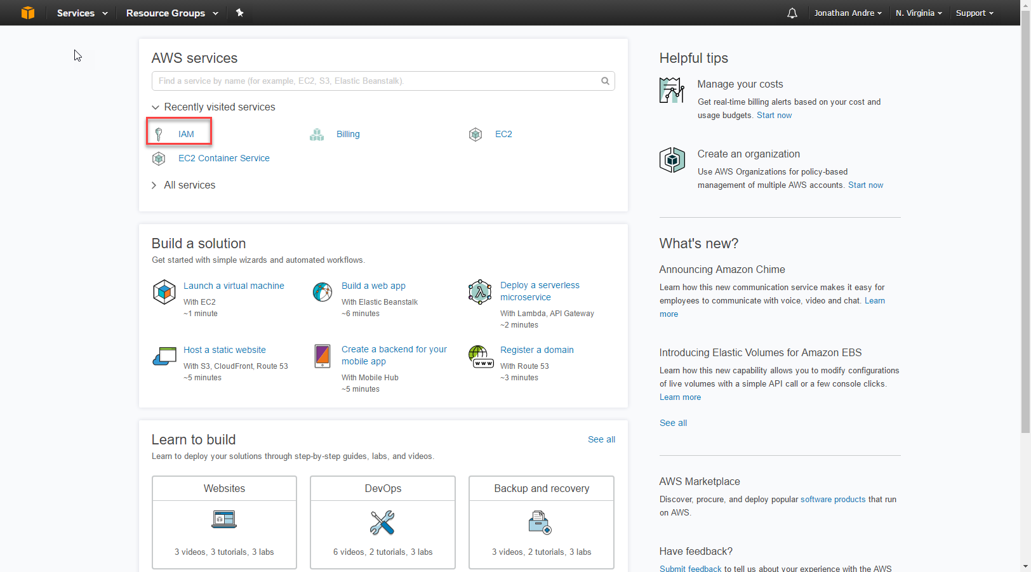

From here, find and click on the “Users” text on the left-hand panel. Once on the user’s panel, select “Add User”:
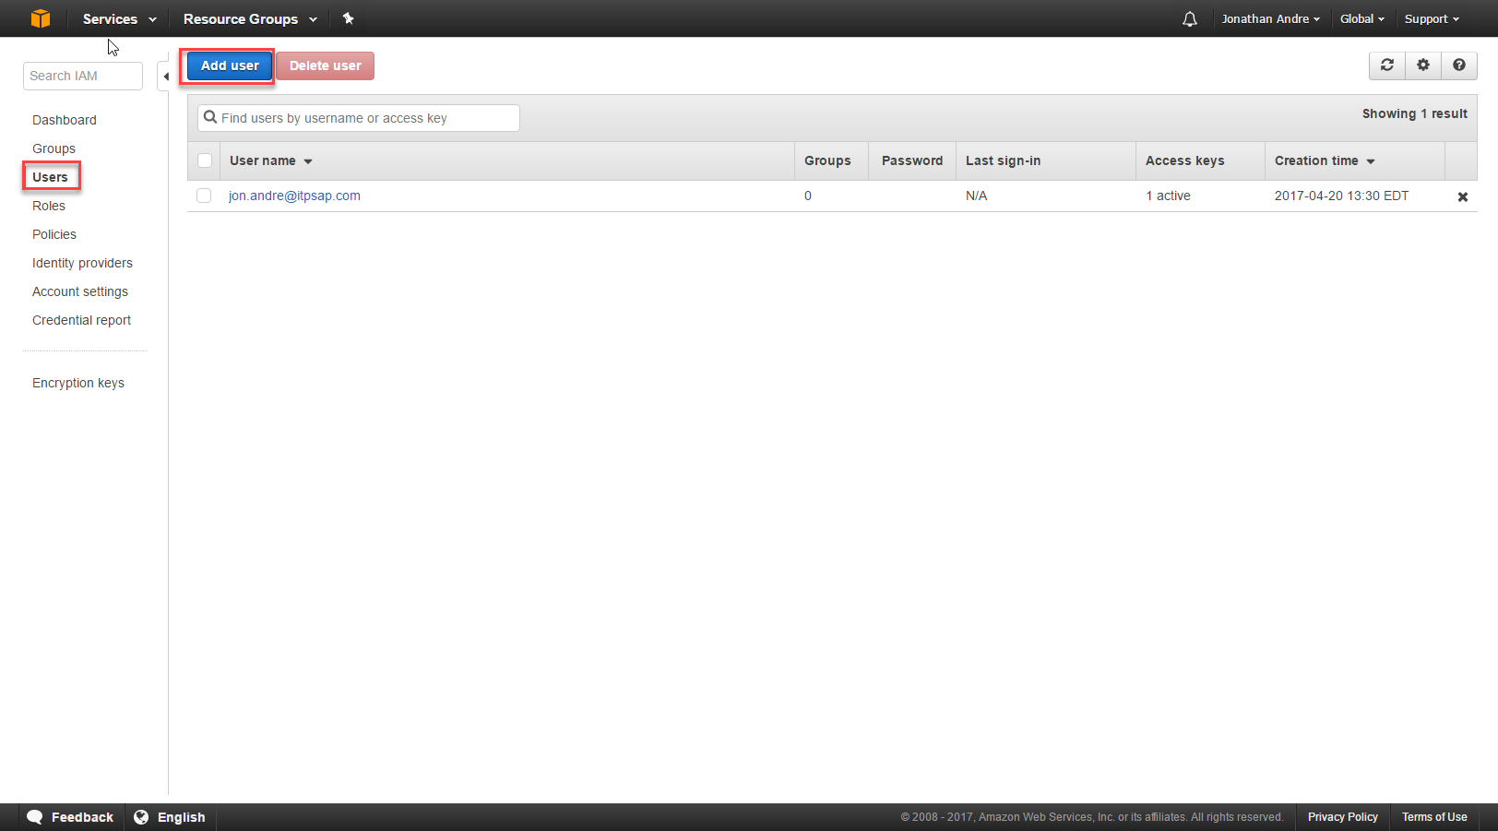
Enter a username of your choice (I just re-entered my email for simplicity) and click the checkbox next to “Programmatic Access”:
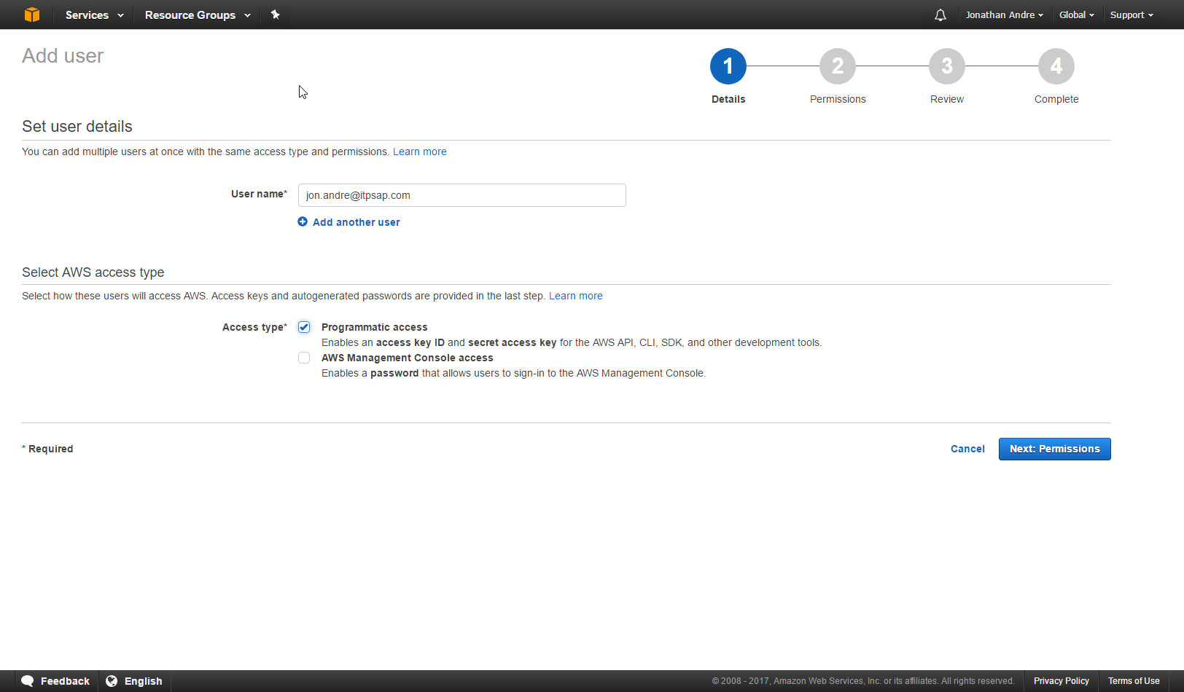

Click next to move on to the “Permissions” section. Within this section select “Attach Existing Policies directly”.
Find the and click the checkbox next to the following policies
AmazonEC2FullAccess
AmazonVPCFullAccess
AWSAccountUsageReportAccess
ReadOnlyAccess

You can utilize the search feature to find these policies faster:
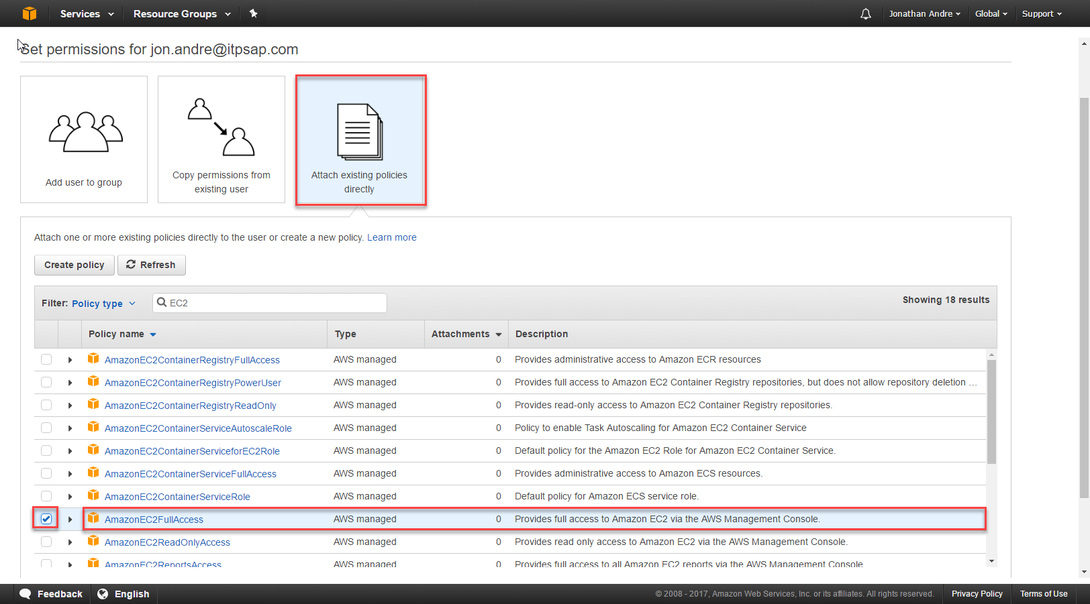

Click next to review the permissions provided. Confirm you have granted the four necessary permissions then hit Create User.
(When searching for the ReadOnlyAccess policy, note that this is actually the policy name! There are other policies that include ReadOnlyAccess. It is not necessary to add these!)

Step 5: Store you Access Key ID and Secret Access Key
After clicking create user, you should be brought to a page that displays your Access Key ID and your hidden Secret Access Key. This combination of keys is what allows you to tie your CAL instance to your AWS account, so you will need to store this in a secure spot.
(AWS will not allow you to see these again. If you lose them, you will have to regenerate the two keys)
Click the “Download .csv” to store the keys as a CSV file.
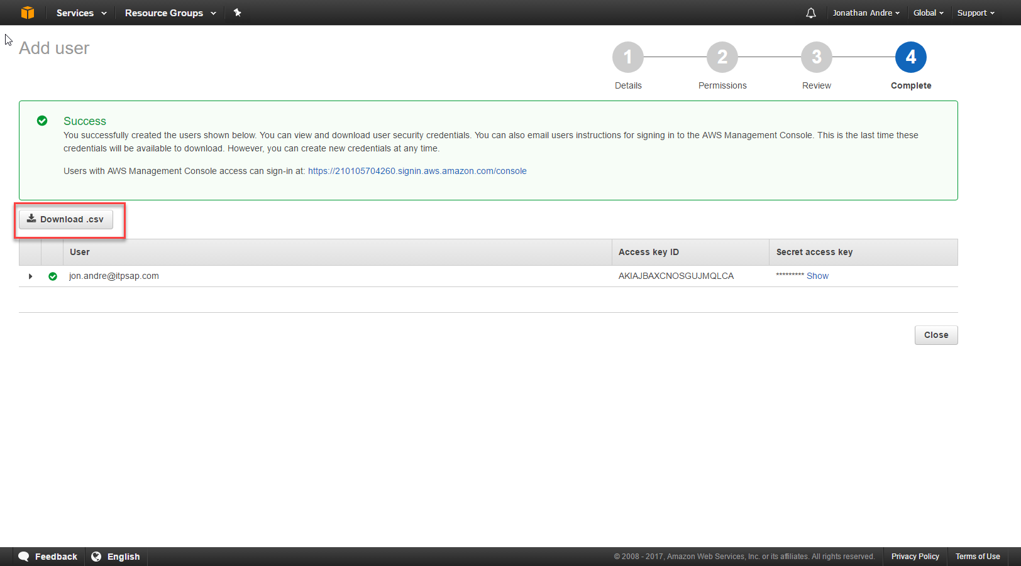

Store this .csv file in a safe place, as you will need it in the next step to configure your NetWeaver instance.

Locate and Install CAL Solution : SAP NetWeaver AS ABAP on SAP HANA
In this part of the tutorial, we will be navigation to the Cloud Appliance Library and setting up an instance of SAP NetWeaver on HANA for our AWS account.

Step 1: Navigate to https://cal.sap.com and log in to your SAP account. If you do not have an account yet, follow the steps to set a new account up.

Step 2: Once logged in, locate the SAP NetWeaver AS ABAP and SAP BW 7.5 SP01 on SAP HANA SP10 [Developer Edition] solution (you can restrict the results by “HANA” to narrow down the solutions.)
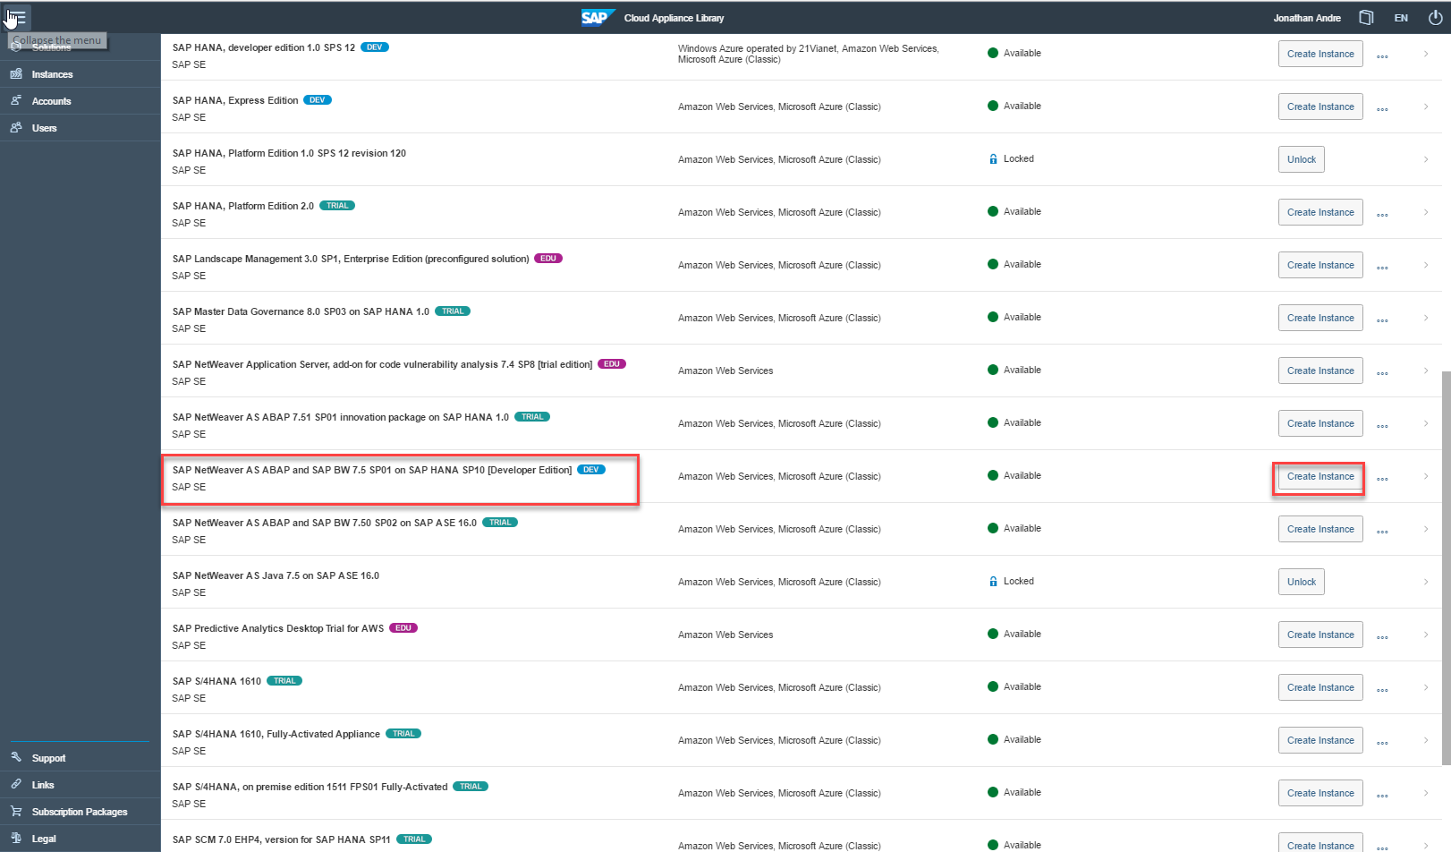

Click “Create Instance” to begin setting up your SAP NetWeaver instance.

Step 3:
Once inside the “Create Instance” screen, select an account of your choosing (default is fine as well).
If you have no account , select the radio button next to “Create a new account”
Enter these details:
Cloud Provider: Amazon Web Services (dropdown)
Access Key: (access key for the CSV file that as downloaded from AWS)
Secret Key: (secret key for the CSV file that was downloaded from AWS)
Hit “Test Connection” to ensure you have the correct keys, and that you have provided the correct user authorizations associated with these keys. If you are missing authorizations, ensure you have completed Step 4 within “Registering for Amazon Web Services” above correctly.
Once the Account Details section is completed, enter the Instance details:
Name: (any name you choose)
Region: (US east is fine if you plan to use it in this area. This may be different if you’re in a different region of the country on Fridays)
Password: (password of your choice. KEEP THIS HANDY! THIS WILL BE THE PASSWORD FOR YOUR INSTANCE AND YOUR SAP USER IDS!)
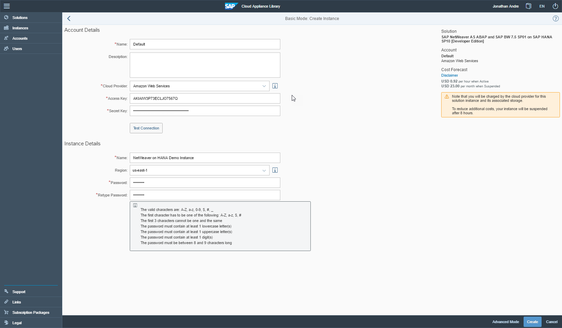
Once all the details have been completely filled in, click “Create” in the bottom right corner of the page.
NOTE THAT YOU WILL BEGIN INCURRING CHARGES AT THIS POINT!!
The charges are minimal however (starting my instance took 90 cents).
Step 5: Store your PEM key:
Hit “Store” then “Download” to save your PEM key:
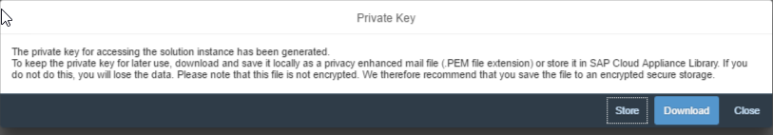

Step 6: Wait for your instance to be configured and started (DO NOT ATTEMPT TO CONNECT BEFOREHAND. It will have a green indicator and say ACTIVE (not ACTIVATING) when finished)
The instance will take between 20-40 minutes to create and start.
Step 7: Once started, connect to the Remote Desktop.
You can do this at any time when an instance is “Active” on the “Instances” page within http://cal.sap.com by clicking the “Connect” button and selecting “RDP”.
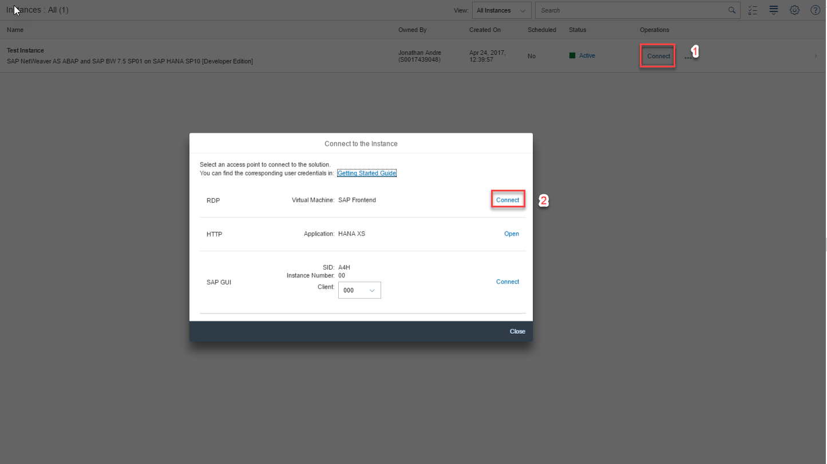
This will download a .rdp file that can be executed in to connect to your instances virtual desktop.
Use the PASSWORD (not any keys) you provided during the instance creation to log into your virtual desktop. You will have to enter password twice (once to connect to the desktop, another time to actually log into the desktop.
Step 8: DO NOT FORGET TO SUSPEND YOUR INSTANCE!!

Suspending the Instance:
Please do not leave your instance running when it is not in use. This will cause you to accrue costs very quickly for something you are not using.
To suspend your instance, click on the instance to navigate to the instance details page (where you can find the IP addresses, instance status, etc).
From here, click on the “Suspend” button on top of the page to suspend the instance.
Note that you will still incur charges while the instance is suspended, but MUCH less than you would if the instance was Active! However, all of your work (programs, data, etc) will be available when you start your instance again.
Terminating the Instance:
Follow the same steps as the suspending directions above, but on the instance details page select “Terminate” instead of “Suspend”.
You will no longer be charged for anything related to this instance once the instance has been terminated, however all work you have created (programs, data, etc) will be lost forever.
This can often be the best option if you don’t care about any programs you created (or you have saved them to your own computer outside of the remote desktop).
If, however, you plan on reusing the instance soon (within the next day or so) it may make more sense to just suspend the instance. Leaving the instance suspended seems to cost around 76 cents per day, while booting the instance will cost around 90 cents before you even get to use it.

Activating License on the CAL SAP System
Step 1: Log into SAP GUI from your remote desktop for your instance
Find and double click the SAP GUI icon on your remote desktop. An SAP system should already hooked up and configured to access the SAP backend associated with your instance.
Log into the system as your normally would. You can the username DEVELOPER or SAP* to log in to the system.

The password is the same password you log into the remote desktop with, and the same password you provide when setting up the system in CAL.
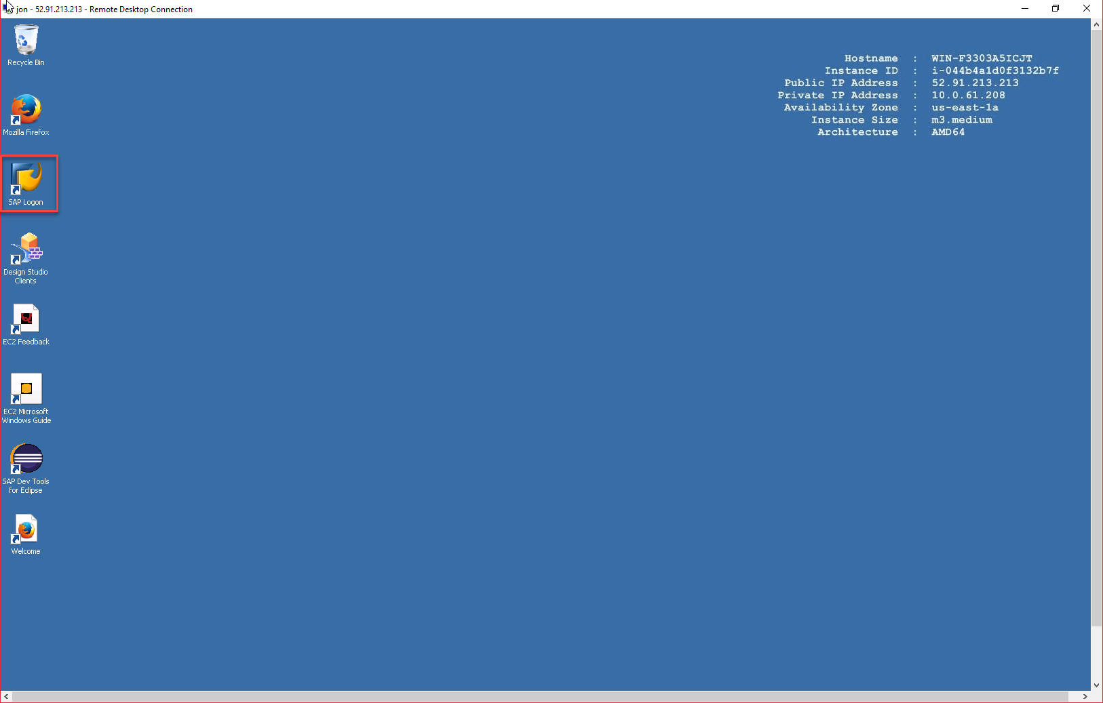

Step 2: Grab the Hardware Key from Transaction Code SLICENSE
Navigate to transaction SLICENSE find and copy the hardware key:
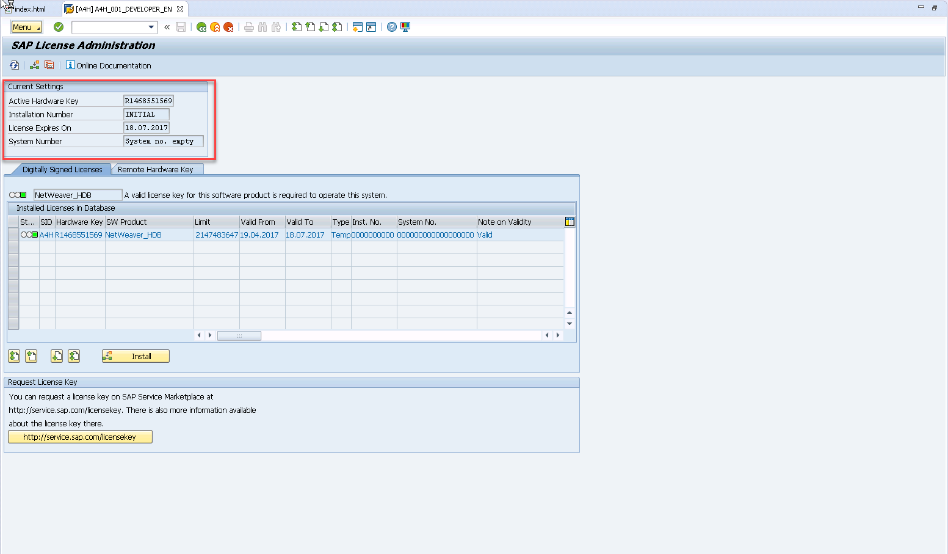

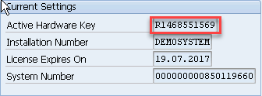

Copy this key into your clipboard.

Step 3: Acquire a License Key from http://sap.com/minisap
Open the web browser and navigate to sap.com/minisap
Select the A4H Instance system (should be first system listed)
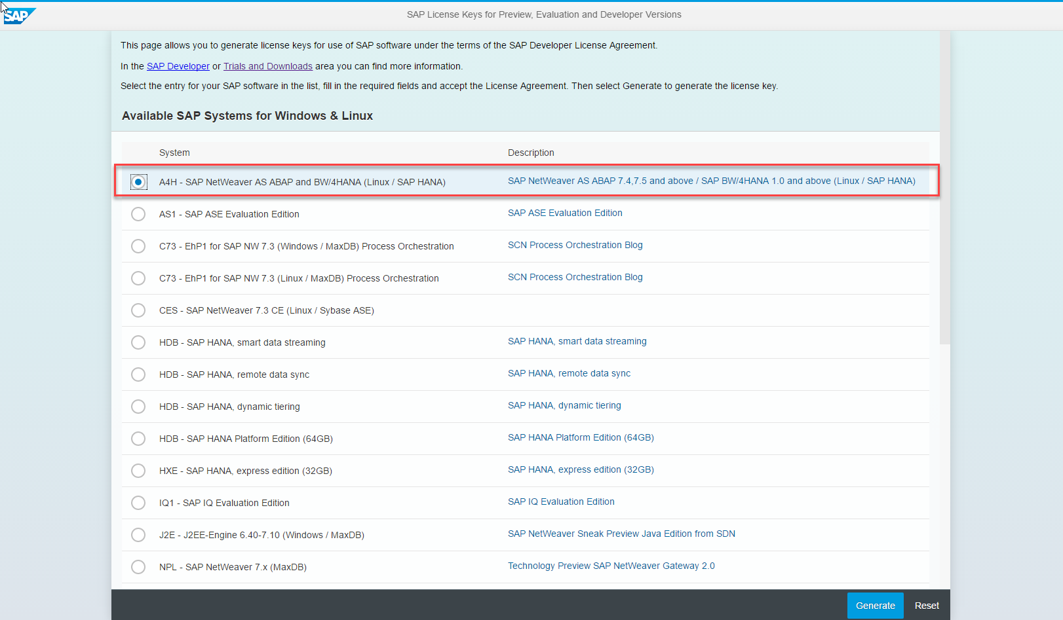
From here, enter your information and paste the hardware key copied into the clipboard in step 2.
Click GENERATE and save the A4H.txt file in a location you can remember (desktop is fine):
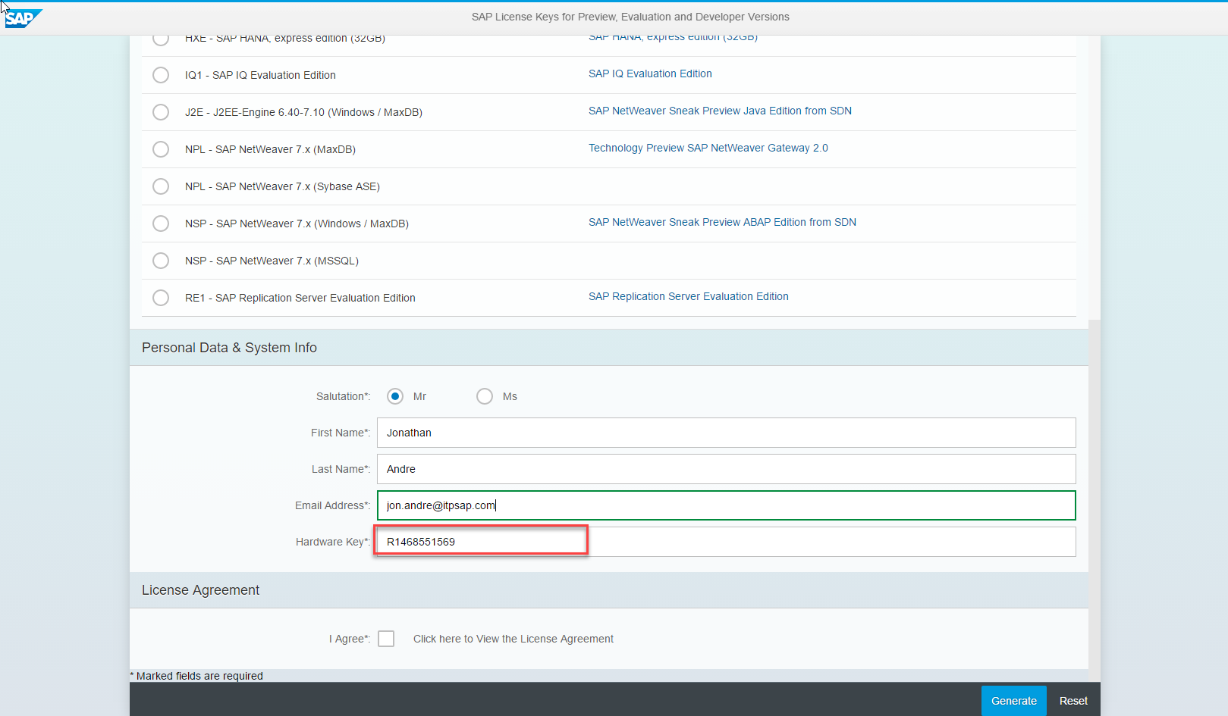
Step 4: Install the license (a4h.txt file) Using SLICENSE
Navigate back to SLICENSE and click the “Install” button around the middle of the screen.
When prompted for a file, locate the .txt file you saved from step 3. Follow the prompts to install this file.
You should receive a success message once this is completed. Your system in now activated:
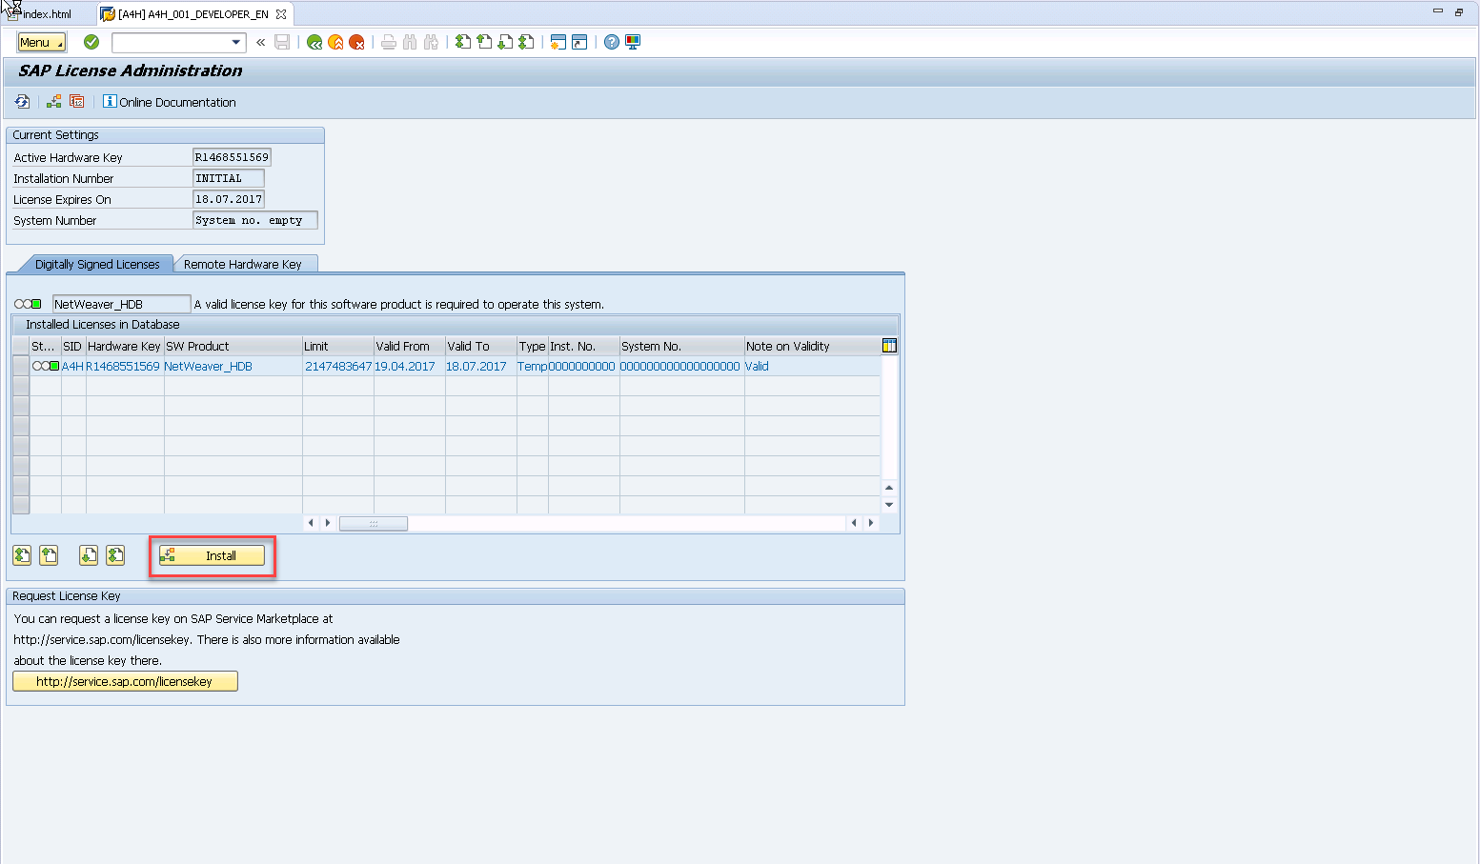

If you are doing this before the Webinar, remember to SUSPEND your system once you’re finished!!
Do not TERMINATE the system, as you will have to go through this activation process all over again!!

